**For window 64 Bits:**

Version:

OMNET 5.6.2

INET: 4.3.5

VEINS: VEINS5.2

SUMO -1.8.0

**Procedure to Install Omnet++.**

1. Extract if its tar file or zip file.

2. Go in OMNET++ 5.6.2 folder and change configure file (user) file and change this line. You have to write no in front of PREFER_CLANG (PREFER_CLANG=no) and save.

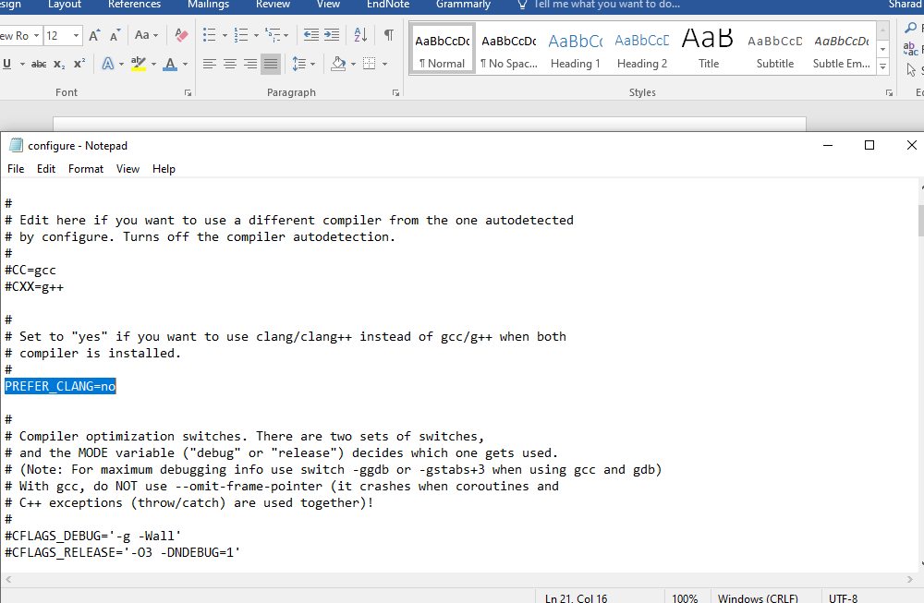

3. Stay in same folder and double click on- mingwenv.

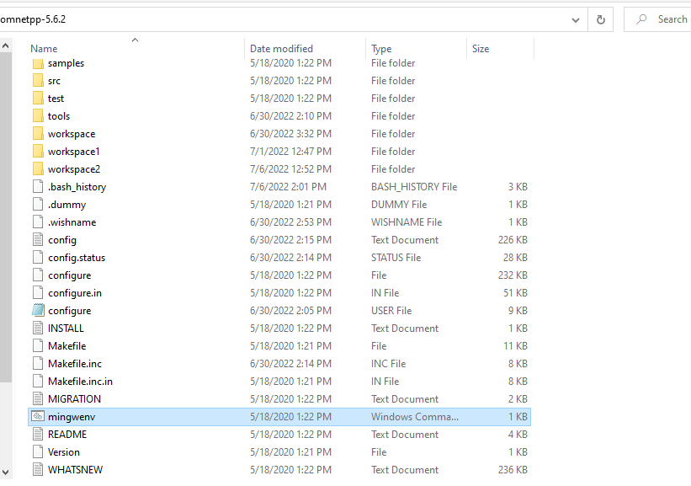

4. Commond prompt will open. Now type. /configure wait after completion you will get message good.

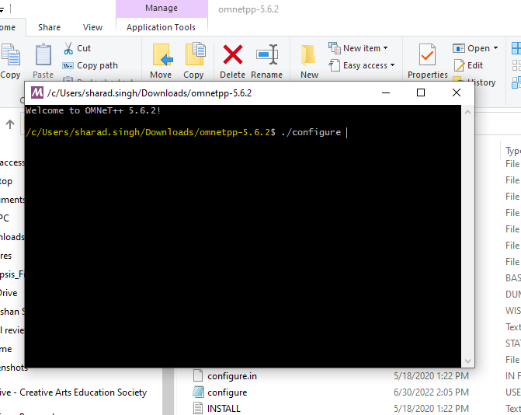

5. Type make in command prompt and enter.

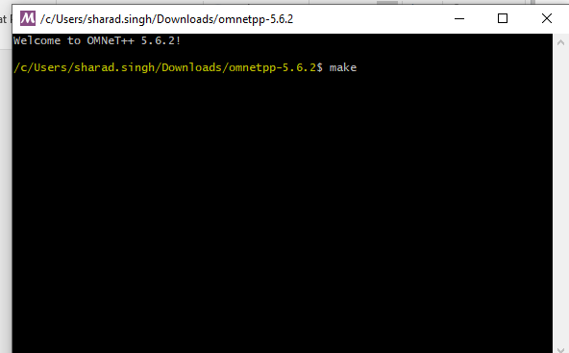

6. Check whether your omnet++ is installed or not .Type cd sample

7. Type cd aloha

8. Then type. /aloha and you will be prompt other window and you can run simulation of aloha.

**ADD INET TO OMNET++:**

1. To open OMNEY++ IDE you have to go in OMNET++ folder double click on - mingwenv. A window will open type **omentpp** and enter.
2. Wait till IDE is open now in project folder right click and click on import project and browse INET 4.0 folder and click on finish.
3. Then click on INET in project folder and right click and build project. It will take time.so wait for message build successful.

**ADD veins to OMNET++:**

Try same steps as you add veins IN OMNET++.After adding veins 5.2 in project explorer right click on it and build project. Wait for a while.

1. Before next download sumo installer and install sumo 1.8.0.
2. Now launch SUMO you have to give the path of launch.py file. That is under veins folder. And then give path of sumo.exe file that is under program files /eclipse/sumo/bin /sumo.exe (your computer may have different path).

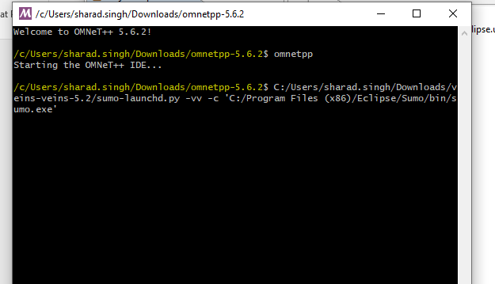

**Note** : If you are going to run any simulation from veins example first launchd sumo as in step 5.You will get a message on cmd sumo is listening 9999 .Then you go OMNET++ IDE and veins/examples/.ini file right click on it and run simulation as omnet++.